 | IOWA DEPARTMENT OF NATURAL RESOURCES  CRT Collection Facility  COLLECTION REGISTRATION FORM |  |  |  |  |  |  | 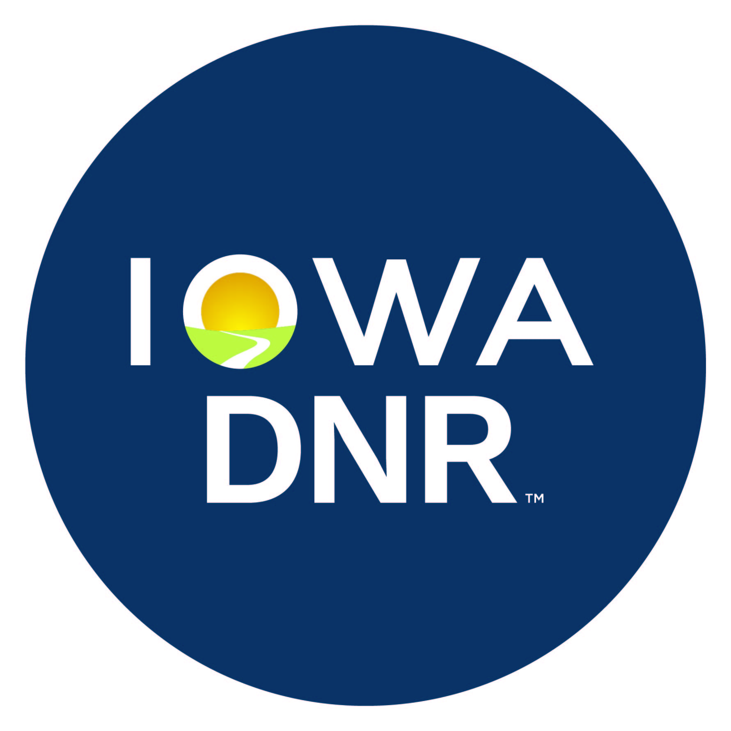
New Registration |  |  | -CRT- |  | - |  | - To be filled in by agency

Facility Contact Information
Facility Information
 | Name: |  |  |  |  |  | Phone:
 | Address: |  |  |  |  |  | Fax:
 | City, State, Zip: |  |  |  | E-mail:
Responsible Official for the Facility
 | Name: |  |  |  |  |  | Phone:
 | Address: |  |  |  |  |  | Fax:
 | City, State, Zip: |  |  |  | E-mail:

CRT Drop-off Location (if different than mailing address):

Certification
IAC 567 122.5(1) - Attach proof of ownership or legal entitlement to use the property for CRT collection.
OR
IAC 567 122.5(2) - If the facility is leased, the applicant shall also include a statement, signed by the property owner, stating that the property owner is aware that CRT collection is taking place at the site and property owner may be held liable for wastes abandoned at the site (below).

Property Owner |  |  | Designated Representative of the property owner
 |  |  | (Provide verification of status as representative)
By signing below, I state that I am the owner or the representative of the owner of the property described in this application. I acknowledge that I or the owner I represent have been informed and are aware of the uses and activities that are ongoing or proposed for the property and consent to those uses and activities. Furthermore, I understand that the issuance by the Iowa Department of Natural Resources, of a Permit/Registration to collect and recycle Cathode Ray Tubes on the property and the terms and conditions of any such registration do not relieve the owner of the Property from any liability, duty, or responsibility arising under Iowa’s Solid Waste Management regulations.
Signature: |  |  |  | Date:
Printed Name:

CERTIFICATION
I certify under penalty of law that I am the owner, operator, or authorized representative of the owner or operator and that I have examined and am familiar with the information reported above, and that I believe the information is true, accurate and complete.

Printed Name: |  |  |  |  | Phone:
Email: |  |  |  |  | Fax:
Signature: |  |  |  | Date:

Return completed application with attached information to: Iowa Department of Natural Resources, Solid Waste and Contaminated Sites Section, 6200 Park Ave Ste 200, Des Moines IA 50321.

