BACKGROUND:
The DNR held a Value Stream Mapping Event (VSM) on October 17 – 20, 2016. This was a collaborative event with six industry representatives and was co-facilitated by the Department of Management.
6 Key Results:
- Optional pre-application meeting
- Optional pre-technical review meetings
- Improved application forms
- Metrics to determine missing information and customer satisfaction
- Critical information earlier in the process
- Directory for just-in-time sharing of internal data
During a 2015 process improvement event for construction permitting, stakeholders expressed interest in an event to facilitate improvements in the Title V permitting process. A diverse set of ideas were gathered in a 2015 best management practices survey of ten state agencies and three regional EPA offices – but what changes do Iowa industries want?
The VSM participants thoroughly dicussed various opportunities to transform Title V permitting and came to consensus on six key deliverables to improve efficiency.
HIGHLIGHTS
The event participants quickly identified that getting complete information was critical for the DNR to efficiently draft a permit and that this should be provided by the applicant early on. The plan identifies specific recommendations and expected timeframes for six high impact deliverables to address this infomration gap: three complex improvements that will take additional time to implement and three quick changes that can be implemeted immediately.
The complex improvements revolve around three areas identified by the stakeholders.
- Establish procedures for optional pre-application meetings
- Establish procedures for optional pre-technical review meetings
- Evaluate and improve the Title V application forms
Since these improvements are more complex in nature the DNR is asking for the input of additional team members.
The DNR has already implemented the following improvements immediately following VSM:
- Developed metrics and track data to reduce additional information requests made by the DNR to and begin customer satisfaction surveys
- Revised the Title V standard operating procedures so that the critical information (electronic spreadsheet of potential emissions) needed to draft the permit is received earlier in the process
- Created directory for just-in-time sharing of data between Air Quality sections relative to Title V permitting

In preparation for the VSM event, the Title V section collected data on the current performance of the section and how it relates to our surrounding states in EPA Region VII. Compared to other states in the region, data shows that:
- Iowa is the state with the lowest percentage of Title V permits older than 5 years (10%)
- Over the last 3 years Iowa has reduced the number of backlogged permits by 13%
- Iowa is the only state to show a cumulative decrease in the percentage of backlogged permits during this period

These positive results were further emphasized by the event participants who determined that the overall steps for drfting aTitle V permit were was already streamlined and customer oriented. Accordingly, the outcome of the VSM will relate to receiving better information from our applicants, thereby improving the efficiency of the DNR staff who will no longer spend time collecting information that could have been provided up front.
NEXT STEPS
Two workgroups will be held between January 17 and 20, 2017 to address the optional pre-meetings and improvements to the application forms. If you are interested in participating in either one or both workgroups, or for additional information, contact Lori Hanson. The workgroups will consist of a diverse group of twelve to fifteen industry representatives.
Expect to hear about these changes during Air Quality Client Contact Meetings, future Title V Training Workshops and on our website at www.iowadnr.gov/airstakeholder listed under Workgroups.
TEAM MEMBERS
Sponsor: Catharine Fitzsimmons
Facilitators: Marcia Tope, Department of Management
Michelle Wilson, Department of Natural Resources
Sub-team Leader: Lori Hanson, Title V Program Supervisor
Customers: Ryan Carlson, MidAmerican Energy Company
Tom Day, Quaker Manufacturing
Justin Ford, Grain Processing Corporation
Nina Harbaugh, Brand FX
Terry Noteboom, Pella Corporation
Bruce Stainbrook, Altec Osceola Body Plant

Other Customers: David Peter, Environmental Protection Agency, Region VII
Dennis Thielen, Compliance Senior Environmental Specialist
Holly Vandemark, Field Office #4 Senior Environmental Specialist
Internal: Tony Daugherty, Linn Co. Senior Air Quality Scientist/Engineer
Chris Kjellmark, Title V Senior Environmental Specialist
Jessica Reese McIntyre, Title V Environmental Specialist

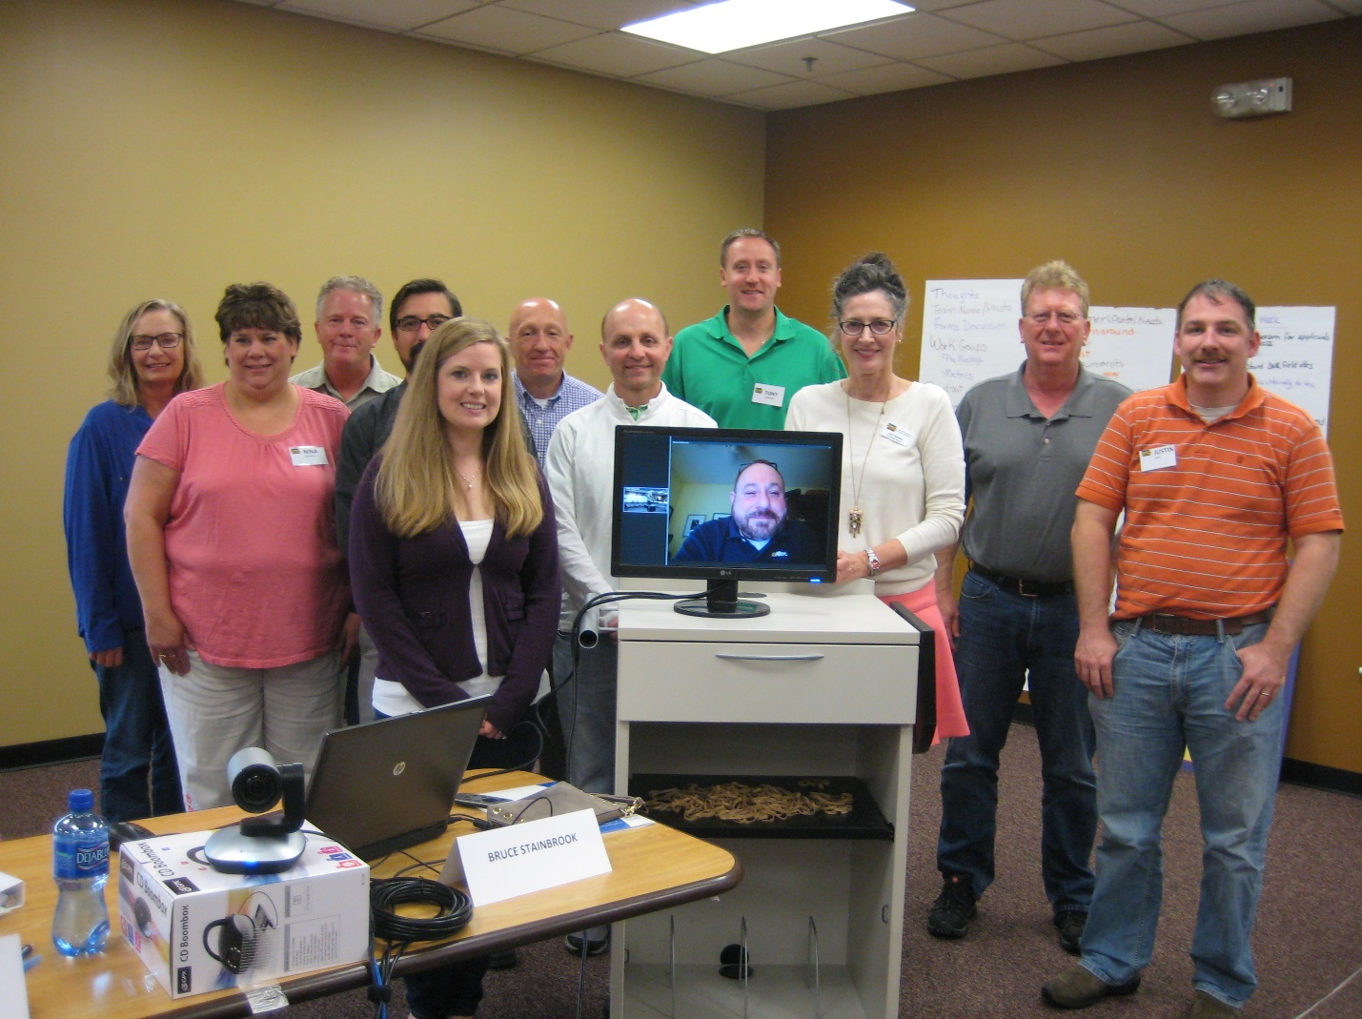

For more information, contact Lori Hanson at (515) 725-9525 or Lori.Hanson@dnr.iowa.gov.

