Water Supply Operations – Enterprise A&A Data Submittal
The Water Supply Operations Section is upgrading our Safe Drinking Water Information System (SDWIS) to a new federal version. Laboratories that use the new web-based Direct Report application and laboratories that use a LIMS system to directly submit data will submit data through the Iowa Enterprise A&A portal. The following URL should be bookmarked:
http://dnrdsmtcat01/directreport/pages/login.aspx

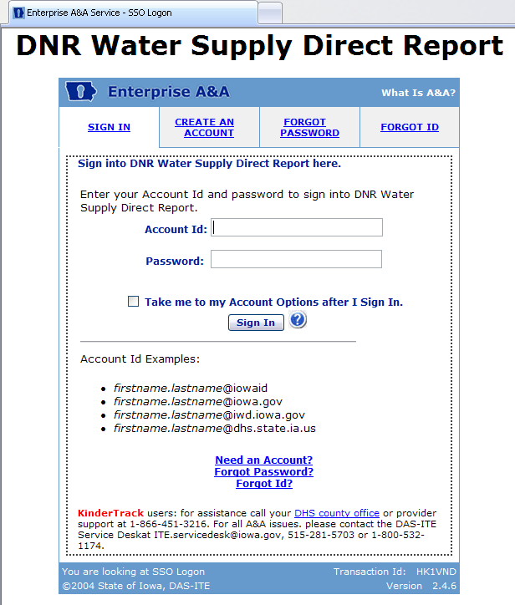

If you need to create an account, use the “Create an Account” tab on the initial Enterprise A&A screen and you will go to the sign up screen. Just follow the instructions to create an A&A account. Remember that you will not be able to access the reporting screens until you have filed the required Reporting Agreement with the Water Supply Operations section and been granted a reporting “role” within the A&A portal.
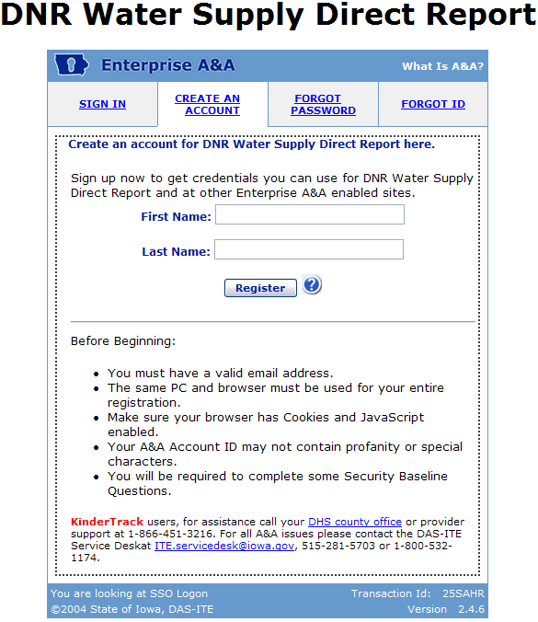

If you know your A&A account ID (email address) and password, you will be taken directly to the initial navigation screen. Here you can choose between the Direct Report and Lab to State applications.
A certified laboratory has two options for reporting electronically, 1) using a combination of Direct Report and Lab to State, where labs enter sample data into the web based Direct Report database and then use Lab to State to submit the Direct Report data to SDWIS, or 2) using their own in-house LIMS database and then using Lab to State to submit the LIMS data to SDWIS. Data submitted to SDWIS must be in an approved XML format. Direct Report will internally generate the required XML files; while, LIMS labs must generate their own XML files.

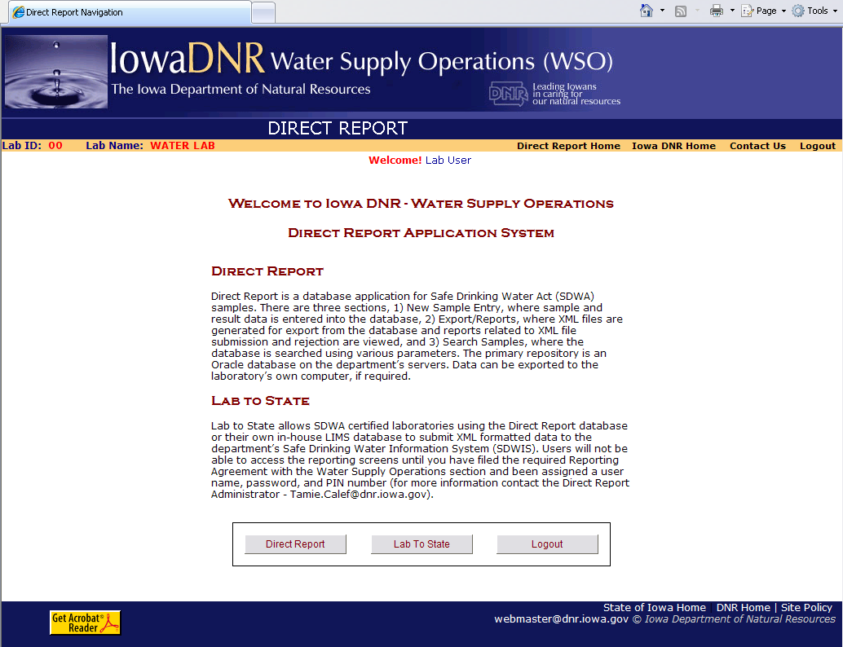

Direct Report
This is the main Direct Report screen. There are three sections, 1) New Sample Entry, where sample and result data is entered into the web database, 2) Export/Reports, where XML files are generated for export and reports related to sample submission and rejection are viewed, and 3) Search Samples, where the web database is searched using various parameters.

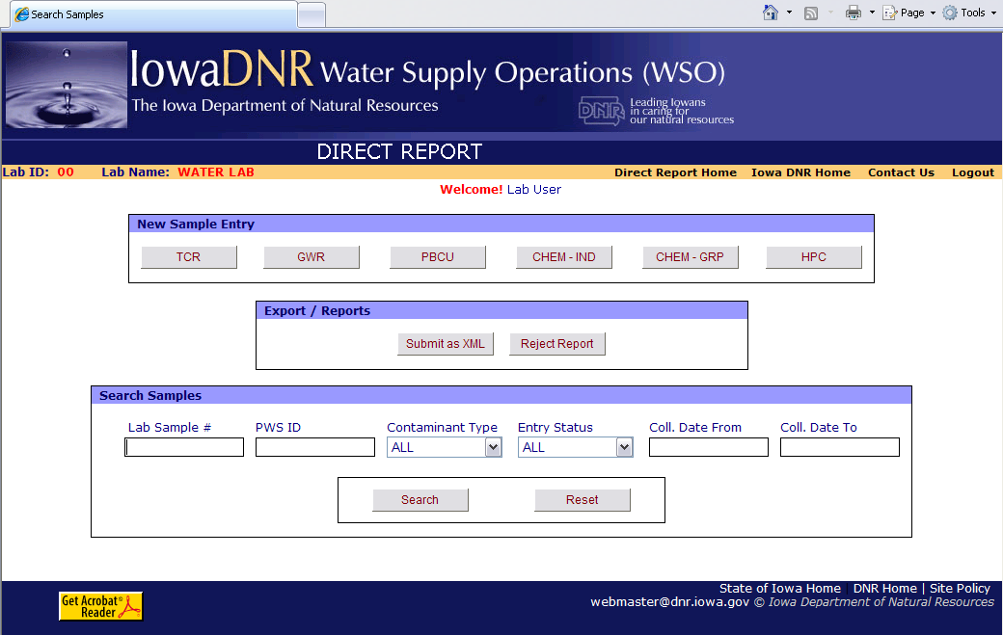

New Sample Entry
In the New Sample Entry section, clicking on one of the buttons will take you to a specific analyte data entry screen. Descriptions of the buttons are as follows:
TCR – Select this button to enter samples and results for the Total Coliform Rule.
GWR – Select this button to enter samples and results for the Groundwater Rule (source water samples). Sample ID types include triggered (TG), additional (AD), assessment (AS), and new well sample (NEW).
PBCU – Select this button to enter samples and results for lead & copper.
CHEM-IND – Select this button to enter samples and results for contaminants other than coliform and lead & copper, such as IOCs, SOCs, VOCs. This button is best used when only one or two contaminants are associated with a sample. Otherwise, the CHEM-GRP button may be of better use.
CHEM-GRP – Select this button to enter results for a group of contaminants associated with a sample. The following is the list of groups available:
- Inorganic Chemicals Series (IOCs) – 10 analytes
- Nitrate/Nitrite Group – 3 analytes
- Radionuclide Group – 6 analytes
- Synthetic Organic Chemical Series (SOCs) – 12 analytes
- Volatile Organic Chemicals Series (VOCs) – 21 analytes
HPC – Select this button to enter samples and results for heterotrophic plate counts.
As an example, the PBCU button will take you to the Lead & Copper Entry Screen. The screen contains the required data elements for Lead & Copper sampling. Once the data fields have been populated, the user can click the Save & New button, where the data is saved and the screen is then ready for additional Lead & Copper data entry; or the Save & Close button, where the data is saved and the screen is closed taking the user back to the main Direct Report screen; or the Close button, where the screen is closed taking the user back to the main Direct Report screen. Note: Be sure to allow pop-ups for the Direct Report website through your internet browser or other toolbars, such as Google or Yahoo. After saving a sample that is at or exceeds the maximum contaminant level (MCL) a data sheet will pop-up that can be saved and e-mailed to the IDNR.
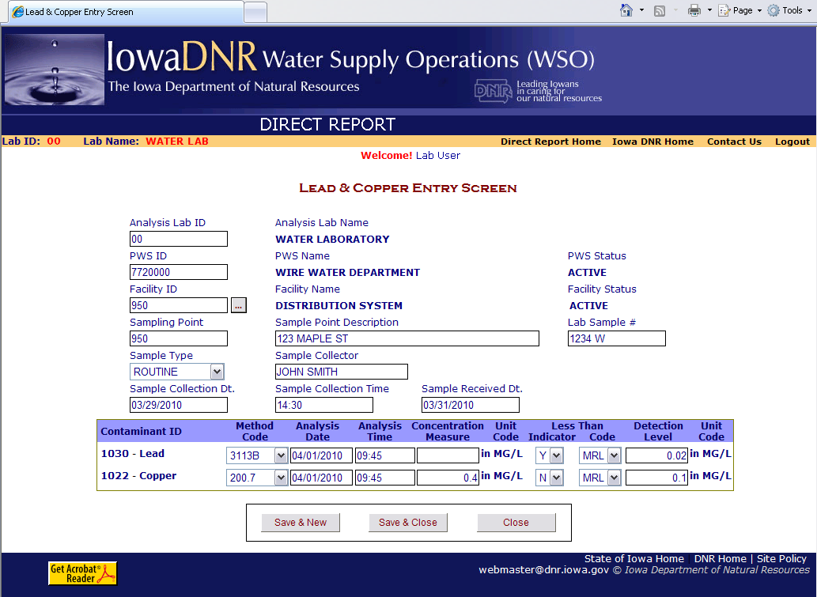

Export / Reports
In the Export / Reports section, clicking on the Submit as XML button will take you to the Submit Samples as XML screen. The default filter on this screen is all the current pending samples (all the sample data which has not been converted into a XML file). Samples can be selected in total, by checking the top box in the header, or individually, by checking the individual boxes in the sample list.

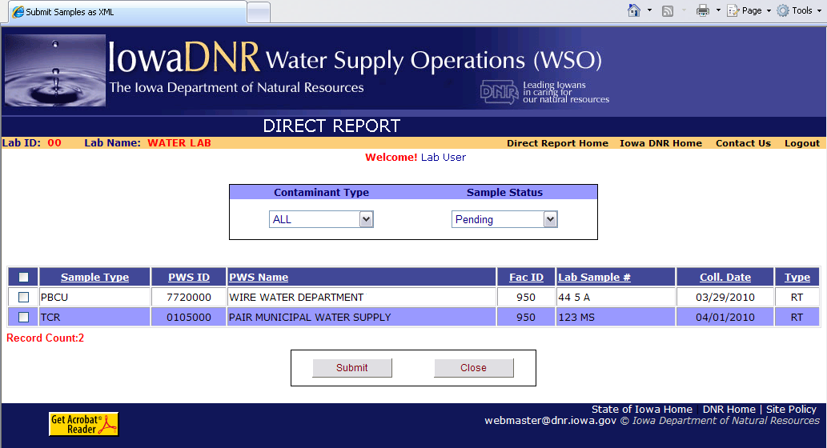

After clicking on the Submit button on the Submit Samples as XML, this dialog box will appear. The user should Save the newly generated XML file.
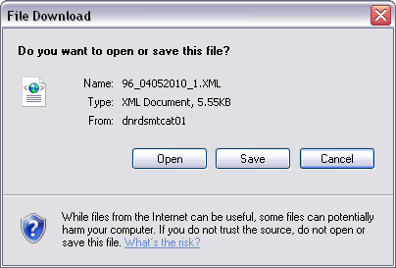

After clicking on the Save button, this dialog box will appear. The user should select a location on the user’s local hard drive (unusually, the C:\ drive) or local server. When finished selecting the location, the user will click on the Save button.
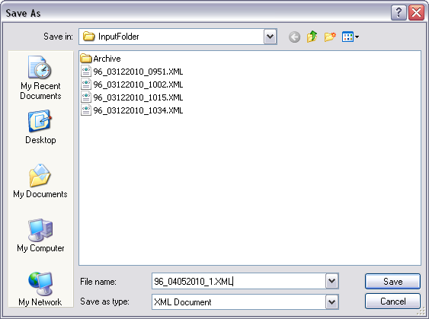

After clicking on the Save button, this dialog box will appear. The user could select the Open button to visually inspect the XML or the Close to close the dialog box. At the end of this operation, the new XML file will be saved on a local hard drive ready for eventual transmittal through the Lab to State application to SDWIS.
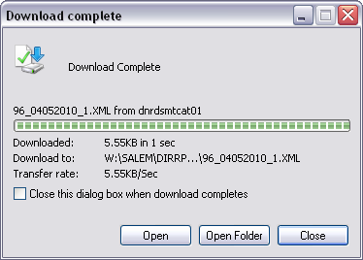

Lab to State
This is the Lab to State data reporting entry screen. Remember that you will not be able to access the reporting screens until you have filed the required Reporting Agreement with the Water Supply Operations section and been assigned a user name, password, and PIN number (for more information contact the Direct Report Administrator - Tamie.Calef@dnr.iowa.gov).

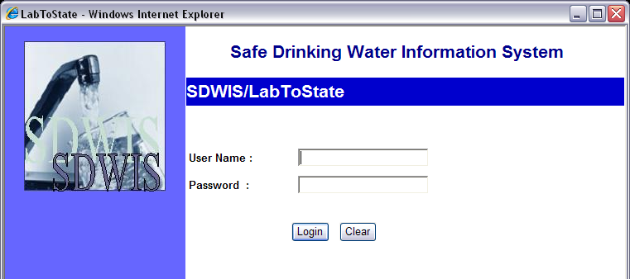

The LabToState Home Page / Job Listing Page presents the Job Listing Table. Click on the Upload & Validate link in the left side of the page to reach the Upload and validate page. This page allows you to submit sample data to SDWIS/XML Sampling. Note: If the file was certified by the laboratory for transfer to SDWIS/XML Sampling, the Certified column contains a “Y.” Otherwise, it contains an “N.”

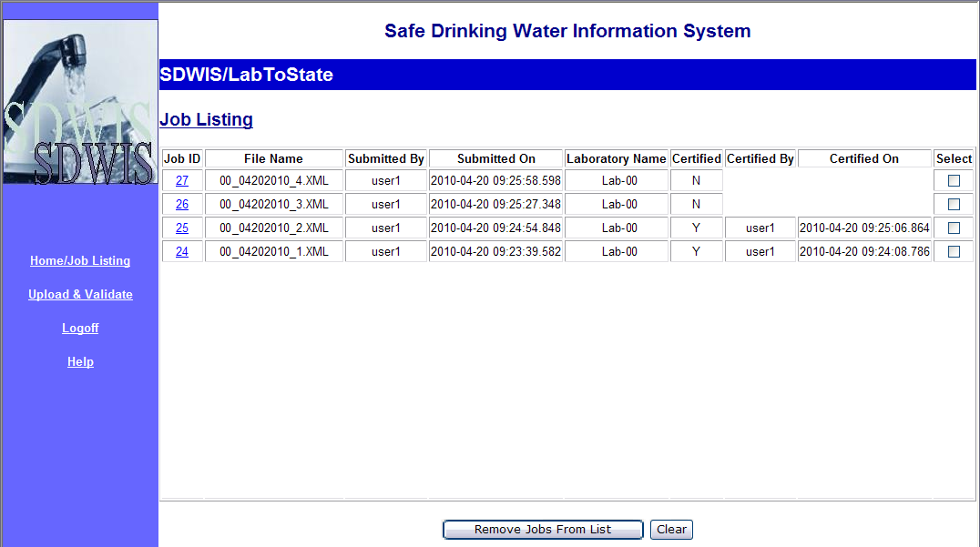

The Upload and Validate page allows you to upload and validate files containing sample data. A file is selected by clicking the Browse… Button.
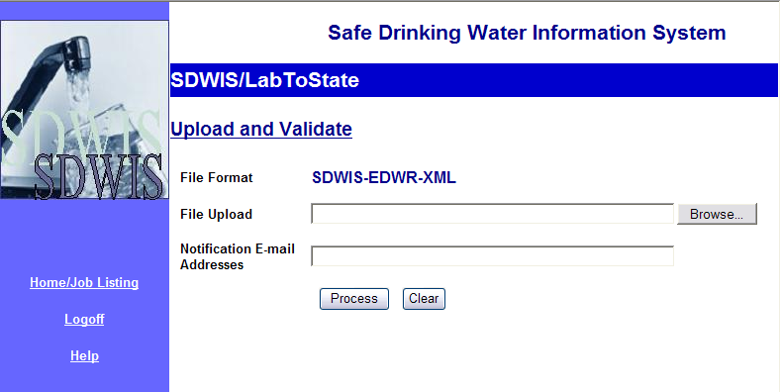

After clicking the Browse… Button, the Choose file dialog window will appear. Select the file you wish to upload and click the Open Button. The File Upload text box will automatically fill in with the complete path and name of the file to be uploaded. Then enter the e-mail address of the person to be notified when processing is complete in the Notification E-mail Addresses text box. Finally, click the Process Button to upload and validate the sample data. Use the Clear Button to clear the text box fields.

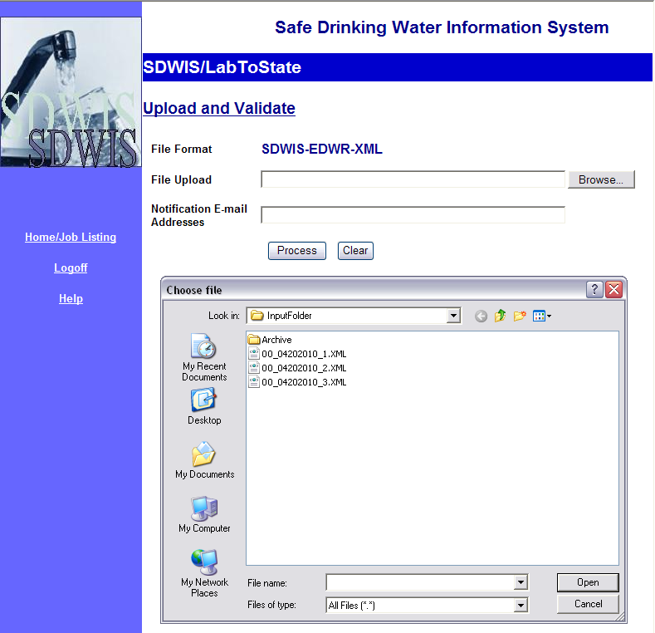

After clicking the Process Button you should see this confirmation page. Click on the Home/Job Listing link in the left side of the page to reach the Home/Job Listing page.
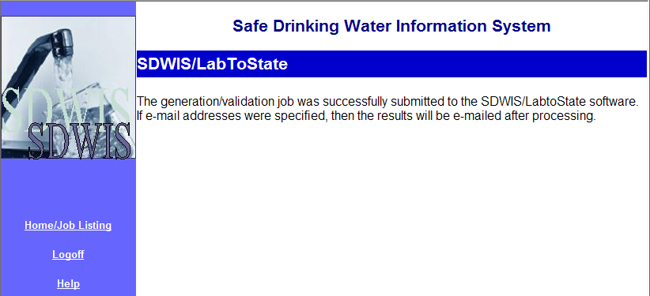

Select the file you wish to certify for transfer to SDWIS/XML by clicking on the Job ID number. This will take you to the Certification Page for that file. Files that have not yet been certified are designated in the Certified column by “N”.

On the Certification Page, click on the View Report link to show the error checking job summery for the selected file.
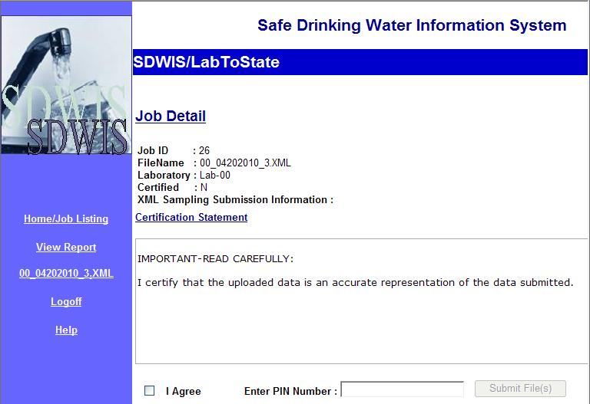

This is the job Summery page. On this summery, one sample with two results was successfully processed.
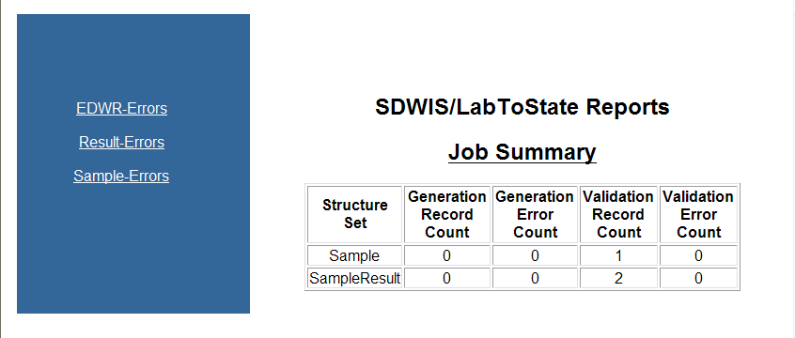

Back on the Certification Page, click on the I Agree box, enter your individually assigned PIN number, and click the Submit File(s) Button. If the file(s) are successfully submitted then the phrase “Files were successfully submitted” will under the main body. Files that have been successfully submitted can be removed from the LabToState Home Page / Job Listing Page by clicking the appropriate box in the Select column and then clicking the Remove Jobs From List Button.

April 22, 2010

