2016 Iowa DNR Canoe & Kayak Schools

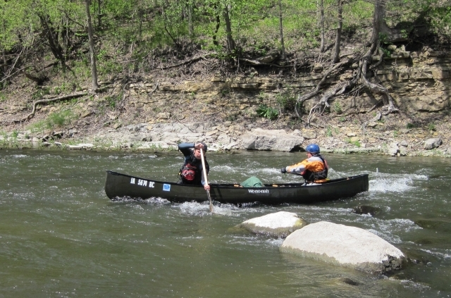
Canoe School on the Boone River

Iowa DNR 2-Day Paddling Schools

Do you often bring others out on the water in canoes or kayaks? Would you like to improve your skills to be able to better demonstrate to others how to paddle efficiently, elegantly, and safely? Join Iowa DNR’s River Programs for a two-day course including classroom and on-water training for tandem and solo canoe. This intensive course will follow the American Canoe Association’s “Intro” and “Moving Water” curriculum, and will be targeted toward those who find themselves teaching others paddling skills, from lakes to rivers. This course will be instrumental for students who plan to enroll in an ACA instructor certification course. You will receive an Iowa DNR certificate of completion. Class size is limited, so sign up today and don’t delay! These classes will fill up fast. By popular demand, we have added a second kayak school for this year.

Prerequisites
This is not considered a novice course, although fairly unskilled people can learn a lot. You are expected to have some previous experience, but not expertise. Please review the ACA course outline you will receive; in the two days, we will cover curriculum for Introduction instruction through the moving water section.
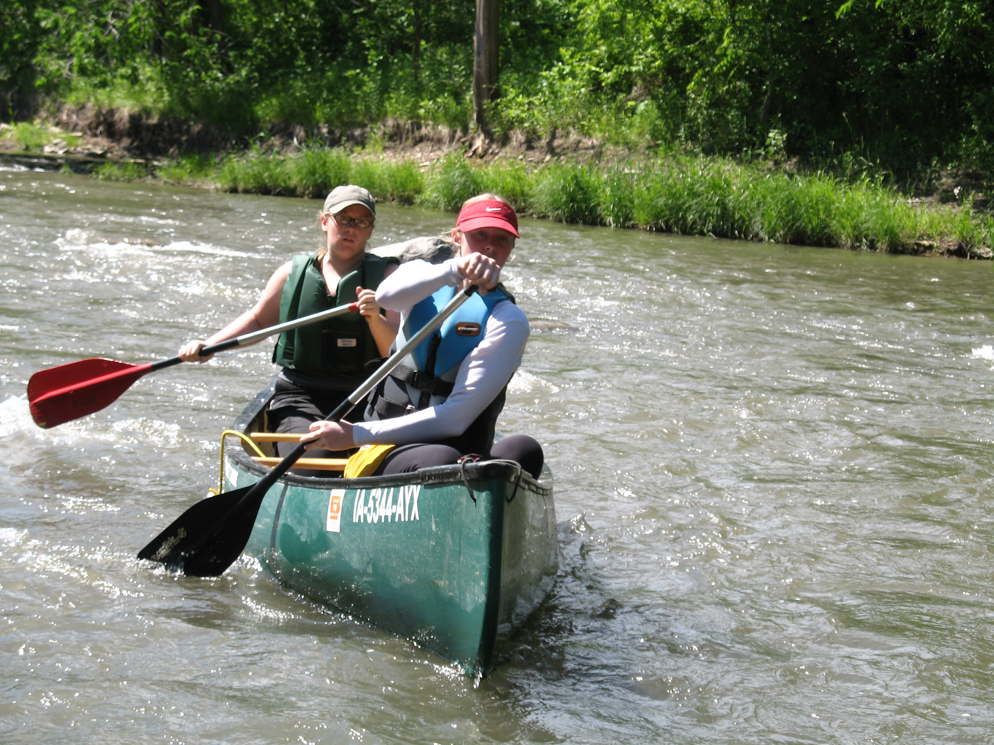

What you’ll need to bring
- Rain gear, brimmed hat for sun, sunscreen
- A small cooler with a lunch to bring during instruction days; you’ll be on your own for breakfast and dinner – there are restaurants in Webster City if you prefer, or bring your own food.
- At least 2 liters of drinking water per instruction day.
- Water shoes or old tennis shoes that can get wet
- Swimming suit and/or clothing that can get wet
- If you have a preferred life jacket (Type III paddlers’ life jacket), bring it; otherwise a life jacket will be provided.
- Sleeping bag & personal effects if staying in a cabin/ dormitory; otherwise bring your own tent and camping gear

The Iowa DNR 2-day Canoe/Kayak School courses (including a one-day flat-water class) are a great way to improve skills for people who help get others out on the water. The intent is to increase safety, lower stress, have fun, and pay knowledge forward, based on American Canoe Association instructional foundations. Time is divided between some classroom and hands-on experience on a lake environment and then a river. Participants from past schools rated the training extremely helpful. They were also surprised by how much there was to learn and how intensive this course is. All classes in 2015 will be held at Briggs Woods, along the Boone River in Webster County. If a different location is needed due to water levels, the Des Moines River is close by and can be utilized as a back-up training location.

Course offerings:

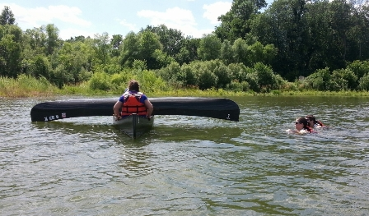
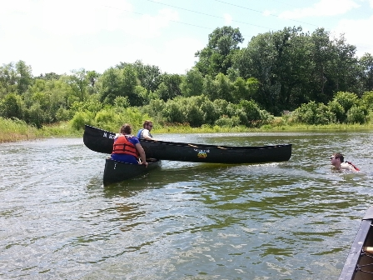

May 11th, Wednesday (10am to 3pm)

“Flat-Water Essentials” Canoe School for Naturalists, Scout Leaders, Youth Group Instructors

Location: Gray’s Lake – Des Moines

Directions: Will be provided to students

Oriented toward: anyone who take groups onto lakes or who are expected to conduct canoe instruction for flat-water conditions only (lakes). The focus is on paddling skills, hazard feature identification, teaching to different learning styles, and risk management. This is for tandem canoe. Boats and life jackets are provided.

Cost: $25

Maximum # participants: 6 – (3 canoes)

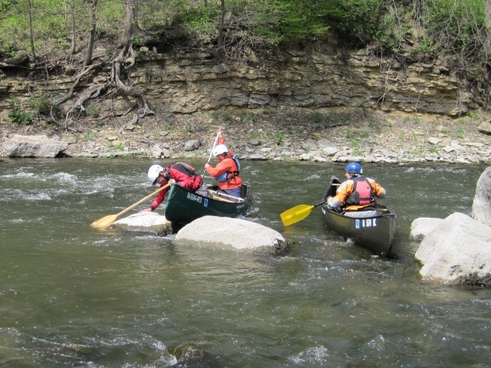

May 24th & 25th (Tues and Wed):

Canoe School for Naturalists and Trip Leaders

Location: Briggs Woods Park, Hamilton County (Boone River)

Directions: http://conservation.hamiltoncountyiowa.com/images/map/master-briggs-2-2-06.pdf

Oriented toward: naturalists who take groups on trips or who are expected to conduct canoe instruction. About 1/3 classroom, and 2/3 on-water, the focus is on skills, hazard and river feature identification, teaching to different learning styles, and risk management.

Cost: $25 (you can camp, rent a cabin or stay in town at a motel)

Maximum # participants: 10 (5 canoes)

Instruction will be conducted by two American Canoe Association certified canoe instructors: Glenn Harman, Nate Hoogeveen

July 5th and 6th (Tues and Wed)

Kayak School

Location: Briggs Woods Park/Hamilton County/Boone River

Directions: http://conservation.hamiltoncountyiowa.com/images/map/master-briggs-2-2-06.pdf
Oriented toward: naturalists who take groups on trips or who are expected to conduct kayak instruction. About 1/3 classroom, and 2/3 on-water, the focus is on skills, hazard and river feature identification, teaching to different learning styles, and risk management. This is for kayak only.

Cost: approximately $25 (you can camp, rent a cabin or stay in town at a motel)

Maximum # participants: 10

Instruction will be conducted by two American Canoe Association certified canoe instructors: John Wenck, Todd Robertson

August 16th and 17th (Wed-Thurs):

Kayak School for Naturalists

Location: Briggs Woods Park, Hamilton County (Boone River)

Directions: http://conservation.hamiltoncountyiowa.com/images/map/master-briggs-2-2-06.pdf

Oriented toward: naturalists who take groups on trips or who are expected to conduct kayak instruction. About 1/3 classroom, and 2/3 on-water, the focus is on skills, hazard and river feature identification, teaching to different learning styles, and risk management. This is for kayak only.

Cost: approximately $25 (you can camp, rent a cabin or stay in town at a motel)

Maximum # participants: 10

September 13th and 14th (Tues and Wed):

Canoe School for Naturalists and Trip Leaders

Location: Briggs Woods Park, Hamilton County (Boone River))

Directions: http://conservation.hamiltoncountyiowa.com/images/map/master-briggs-2-2-06.pdf

Oriented toward: naturalists who take groups on trips or who are expected to conduct canoe instruction. About 1/3 classroom, and 2/3 on-water, the focus is on skills, hazard and river feature identification, teaching to different learning styles, and risk management. This is for canoe only.

Cost: $25 (you can camp, rent a cabin or stay in town at a motel)

Maximum # participants: 10 (5 canoes)

Registration Form:

Please check the course you will attend:

___May 11th, “Flat-Water Essentials” (lake only) Gray’s Lake DSM
($25 FOR NATURALISTS TRIP/GROUP LEADERS or INDIVIDUALS)

___May 24th and 25th, Boone River Canoe School (Briggs Woods)
($25 FOR NATURALISTS or TRIP LEADERS)

___July 5th and 6th, Boone River Kayak School (Briggs Woods)
($25 FOR NATURALISTS, TRIP LEADERS or INDIVIDUALS)

___August 16th and 17th, Boone River Kayak School (Briggs Woods)
($25 FOR NATURALISTS, TRIP LEADERS or INDIVIDUALS)

___September 13th and 14th, Boone River Canoe School (Briggs Woods)
($25 FOR NATURALISTS OR GROUP LEADERS)

Name: _______________________________________________________________

Organization: _______________________________________________________________

Street address: _______________________________________________________________

City/State/Zip: _______________________________________________________________

E-mail: _______________________________________________________________

Phone: _______________________________________________________________

Total fee enclosed: $ ___________
Check should be made out to “Iowa DNR” and sent to:

Iowa DNR
c/o Todd Robertson, River Programs
502 E. 9th Street
Des Moines, IA 50319-0034

Contact:
For any questions, please contact Todd Robertson at 515-979-9538 or 515-725-2960 or email: todd.robertson@dnr.iowa.gov

